
California State University Northridge
ECE 528/L - Robotics and Embedded Systems Lab

L.O.G
Lethal Offensive Gear
Final Project Proposal

Group 3
Antonio Anzora Jr
Vartan Chakryan
Instructor: Aaron Nanas
Fall 2025
Objective:
The goal of this project is to build a small mobile robot that can move around, sense another robot, and gently tap it with a tail attached to a servo motor. The tail will be soft and control to ensure its does not cause any damage. The robot will use the ESP32 WROOM microcontroller to control it motors, read sensors, and operate the tail. It will make use of GPIO pins, PWM signals, timers, and interrupts to perform these tasks. The robot can be controlled manually through a simple web interference or operate autonomously to follow an opponent and tap it when within range. This project demonstrates mobility and sensor integration.
Background and Methodology:
L.O.G utilizes concepts such as interrupts, pulse-width modulation (PWM), general purpose input/output (GPIO) to demonstrate the integration of hardware and software in robotics application. The project explores how embedded principles can be applied to create a mobile robot controlled either through a web interface or Bluetooth connection. A simple web will be developed to enable the remote control of Wi-Fi, allowing users to drive the robot or operate its tail mechanism. By combining GPIO, PWM, timers, and interrupts, the project will provide us a deeper understanding of how these hardware peripherals interact to achieve coordinated movement and responsive control. PWM signals will manage the speed and direction of the motors through a motor driver.
Hardware Components:
Description | Quantity
ESP32 WROOME DevKit C (MCU) | 1
TB6612FNG Motor Driver | 2
DC Gearbox Motor – TT Motor | 4
Orange and Clear TT Motor Wheel | 4
7.4 Tenergy Li-ion 2200 maH Battery | 1
Making Chassis & Tail in Fusion 360 | 1
LM2596 Buck Converter | 10
Servo Motor | 1
TI RSLK MAX RobotKit | 1
USB-A to Micro-USB Cable | 1
Ultra Sonic Sensor (Maybe) | 1
Software Components:
- Fusion 360
- Visual Studio Code (VSCode)
- Platform IDE/Arduino IDE/Espressif-IDE
- Code Composer Studio
Peripherals Used:
SysTick, Timers, PWM, and GPIO
Block Diagram:
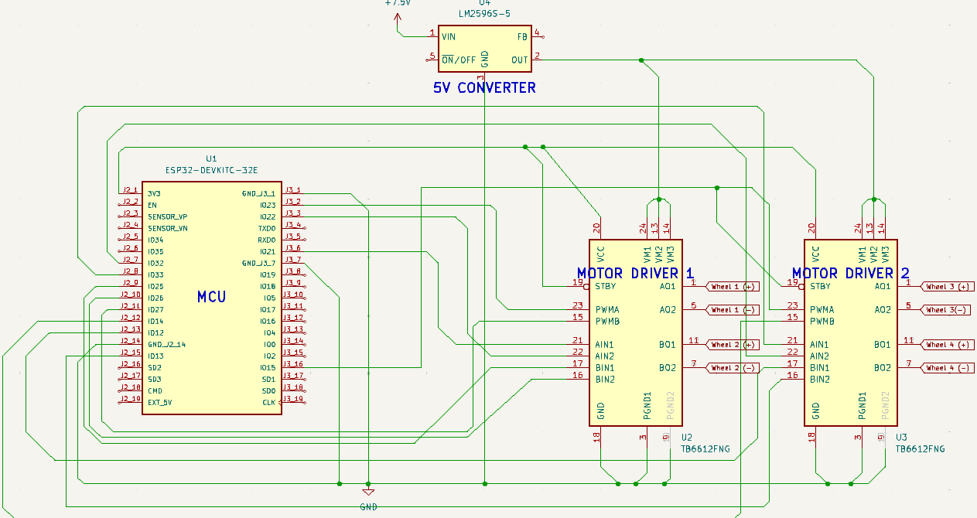
Pinout Plan:
Component | Function | GPIO Pin(s) | Notes
Motor A | AIN1, AIN2, PWMA | 21,22,23 | Controlled through TB6612FNG Driver 1
Motor B | BIN1, BIN2, PWMB | 18,19,5 | Controlled through TB6612FNG Driver 1
Motor C | AIN1, AIN2, PWMA | 16,17,2 | Controlled through TB6612FNG Driver 2
Motor D | BIN1, BIN2, PWMB | 25,26,27 | Controlled through TB6612FNG Driver 2
Servo Motor (Tail) | PWM Signal | 13 | Chosen for PWM-capable pin
Ultrasonic | Trigger, Echo | 32 (Trig), 33(Echo) | Used for obstacle or opponent detection
Battery Input (via Buck Converter) | VIN/GND |  | No GPIO control; Powers MCU and motor drivers
Web Control Interface (ESP32 Wi-Fi) |  |  | No dedicated pins needed; handled via Wi-Fi module

